Practical - 2
Practical Title: Semantic HTML5 Pages with Accessibility-Ready Structure

Problem Definition: Develop static HTML5 skeletons for at least 10 StudentHub pages such as Home, About, Register, Login, Dashboard, Events, Profile, Contact, Admin, FAQ, and Feedback. Use semantic tags and accessibility-friendly structure.

Theory

1. Are semantic tags such as header, nav, main, section, article, aside, and footer used properly?
Answer: Yes. Each page uses <header> for the top logo/title area, <nav> for the menu links, <main> to wrap the page's central content, <section> to group related content blocks (like "Upcoming Events"), <article> for self-contained pieces like one event or FAQ entry, <aside> for side information such as quick links, and <footer> for copyright/contact info. Using these instead of generic <div> tags makes the structure meaningful to both browsers and anyone reading the code.

2. Are form labels, headings, image alt text, and navigation links accessible?
Answer: Every form input on the Register/Login/Contact pages has a matching <label for="..."> so screen readers announce what the field is for. Headings follow one <h1> per page followed by <h2>/<h3> in order, without skipping levels. All images have descriptive alt text (e.g. alt="StudentHub logo") so they still make sense if the image fails to load or is read aloud. Navigation links use clear text like "Dashboard" instead of vague text like "click here".

3. Is the page structure consistent across all pages?
Answer: Yes, all pages share the same <header>, <nav>, and <footer> markup copied identically, so the navigation looks and behaves the same everywhere - only the <main> content changes per page. This was checked by comparing each page's HTML skeleton side by side before adding page-specific content.

Implementation/ Output/Result

The StudentHub portal was planned with 10 pages - Home, About, Register, Login, Dashboard, announacment, feedback, fees, and attendance. A sitemap was made showing public pages (open to everyone) and role-based pages (Dashboard/Admin, visible only after login). A low-fidelity wireframe was sketched for each page layout. The project folder structure and README.md were created and pushed to a new GitHub repository.
<!DOCTYPE html>
<html lang="en">
<head>
<meta charset="UTF-8">
<meta name="viewport" content="width=device-width, initial-scale=1.0">
<title>StudentHub - Home</title>
<link rel="stylesheet" href="css/style.css">
</head>
<body>
<h1>Welcome to StudentHub</h1>
<p>Manage your attendance, fees, and announcements all in one place.</p>
</body>
</html>

Evidence of Work (Screenshots)

Home page :
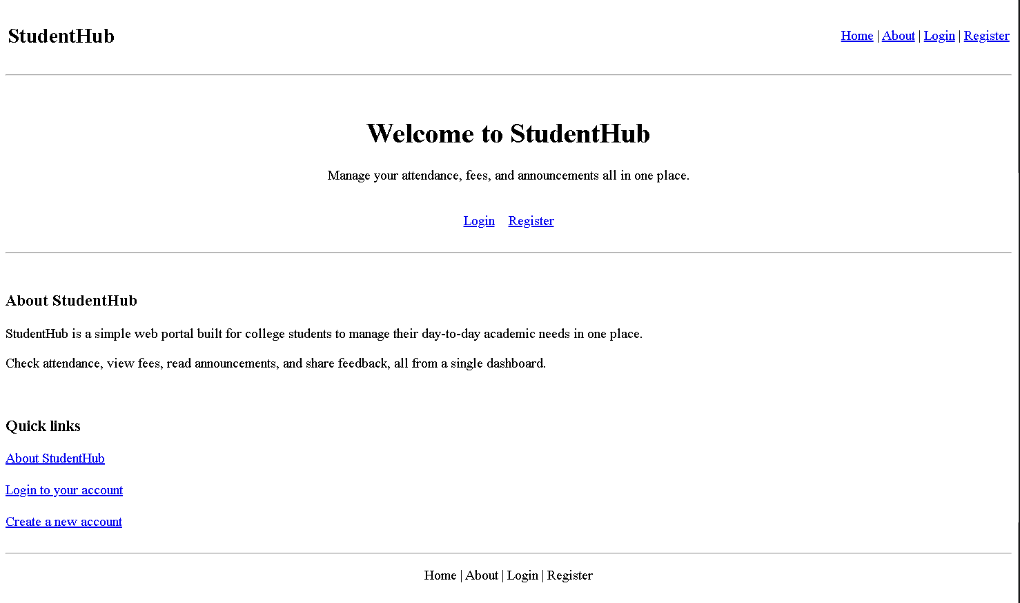
Login page :
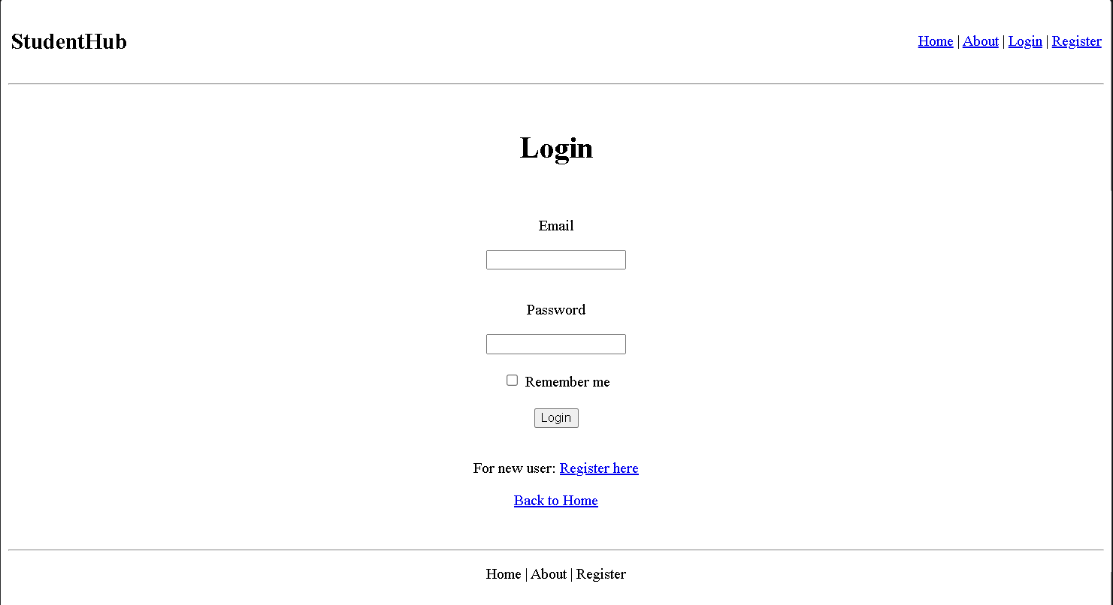

Register page :
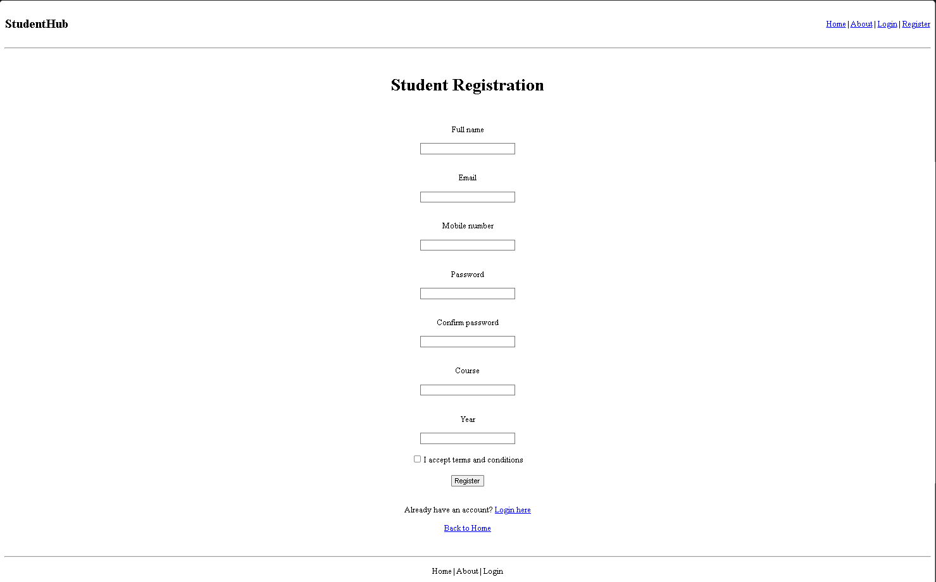

About page :
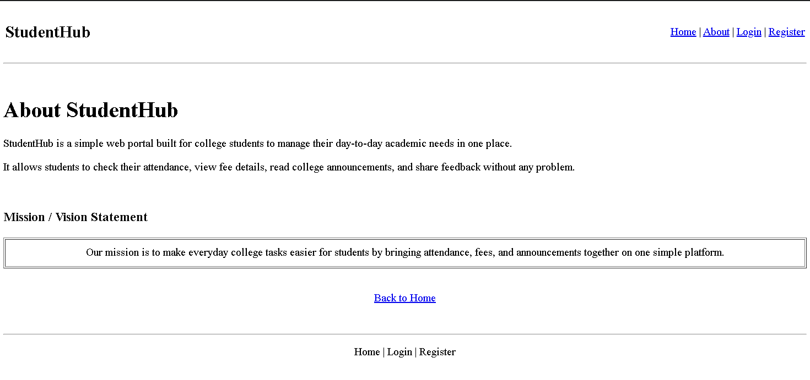

Dashboard page :
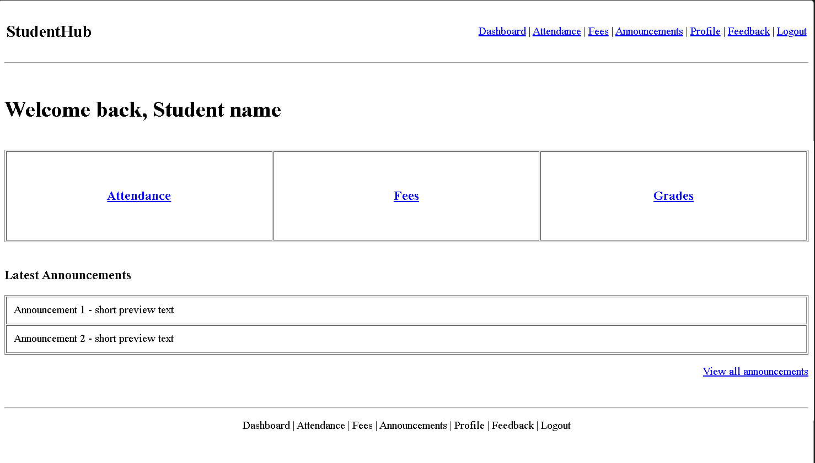

Attendance page :
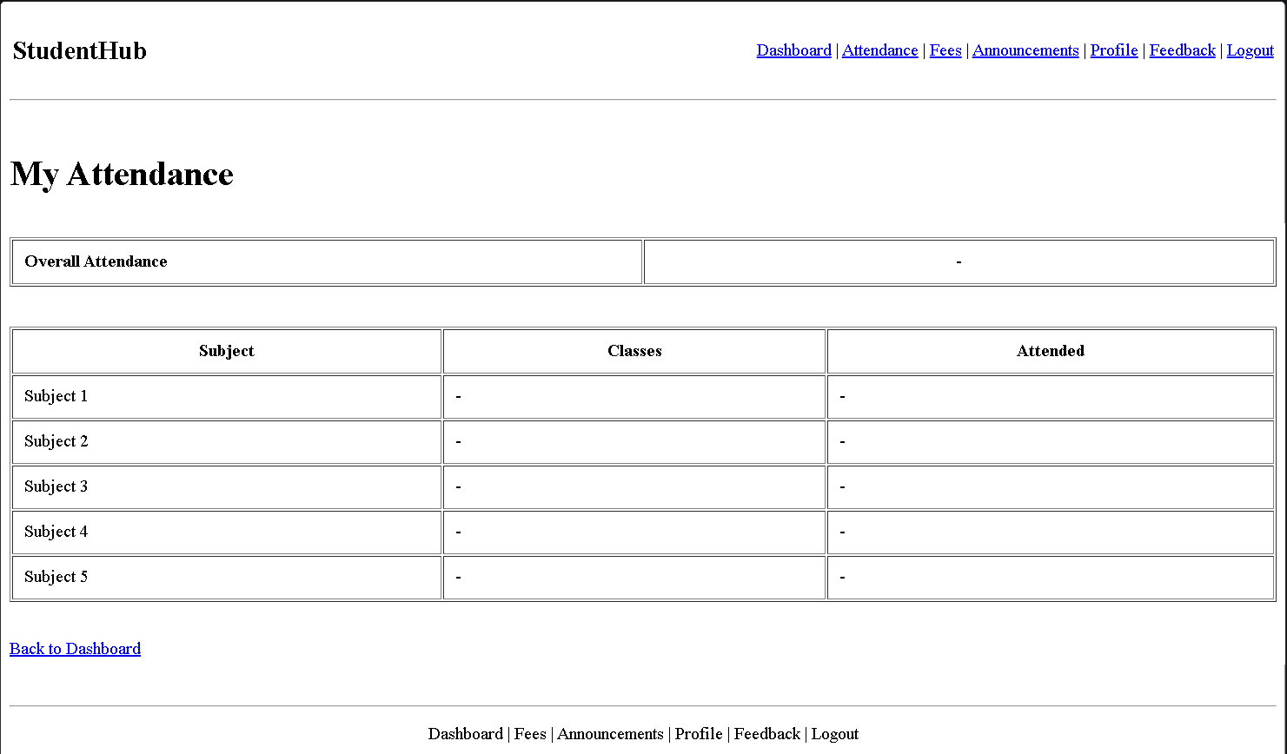

Fees page :
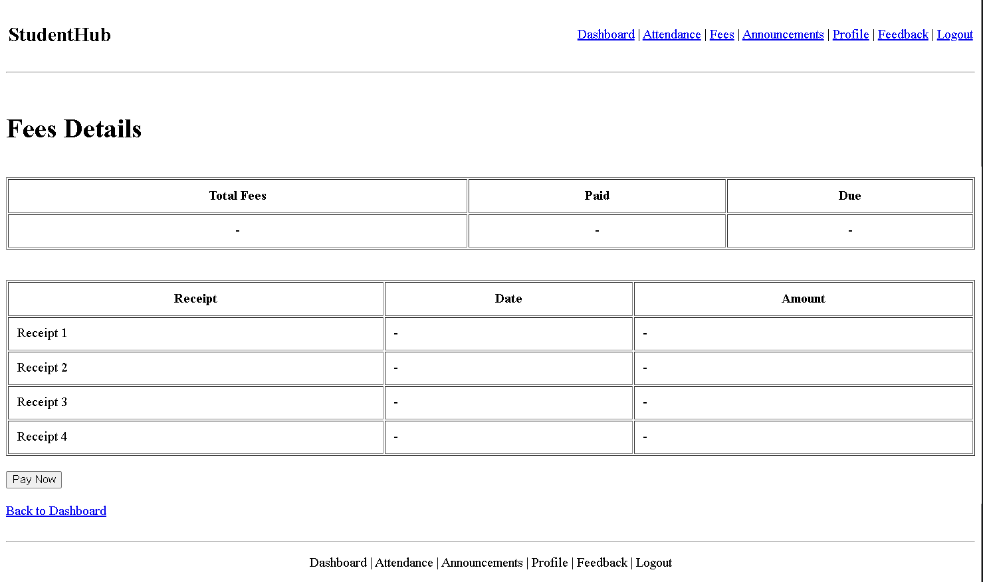

Announcements page :
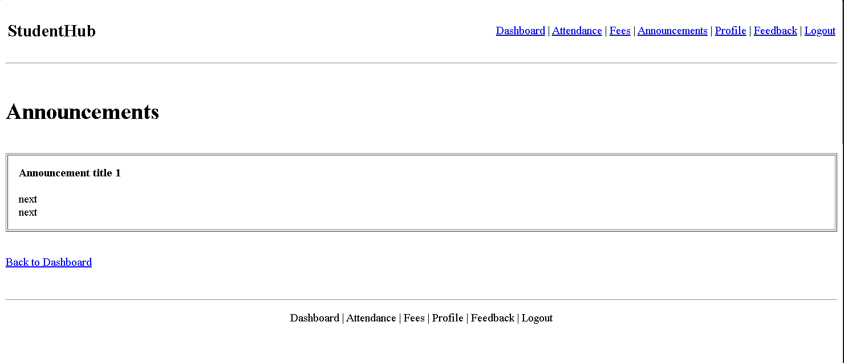

Profile page :
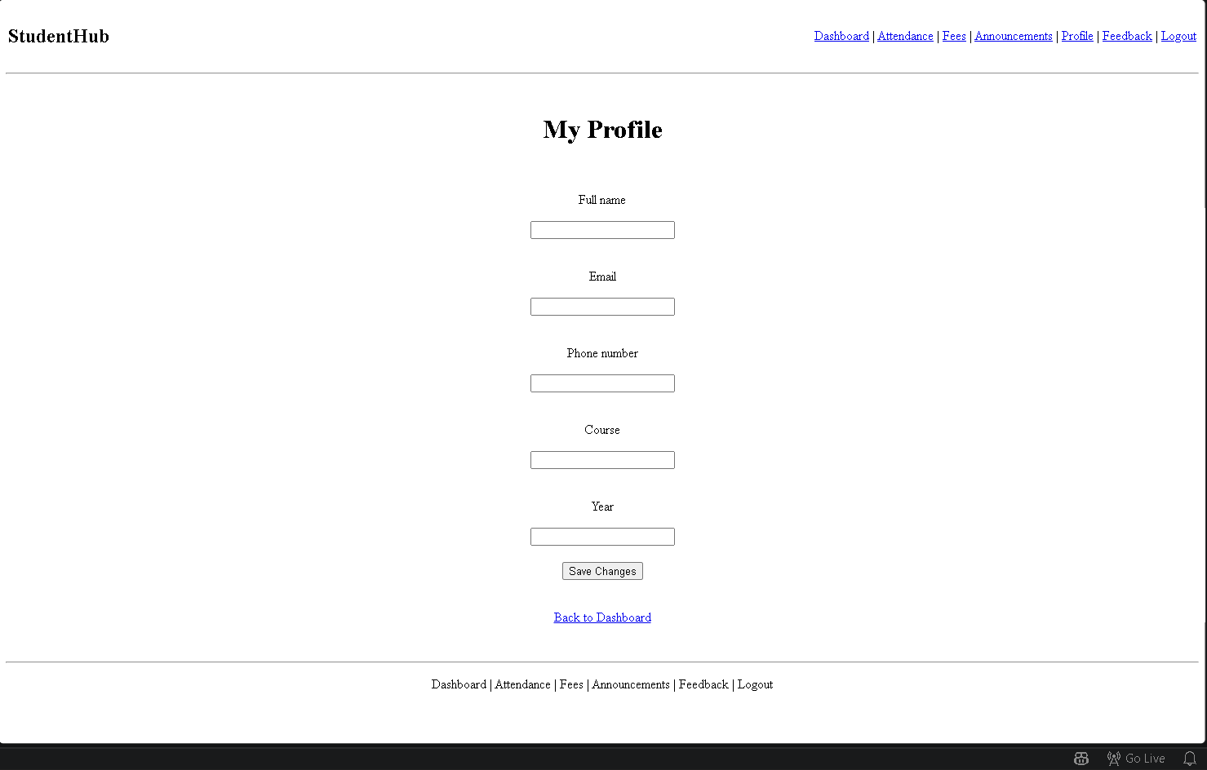
Feedback Page :
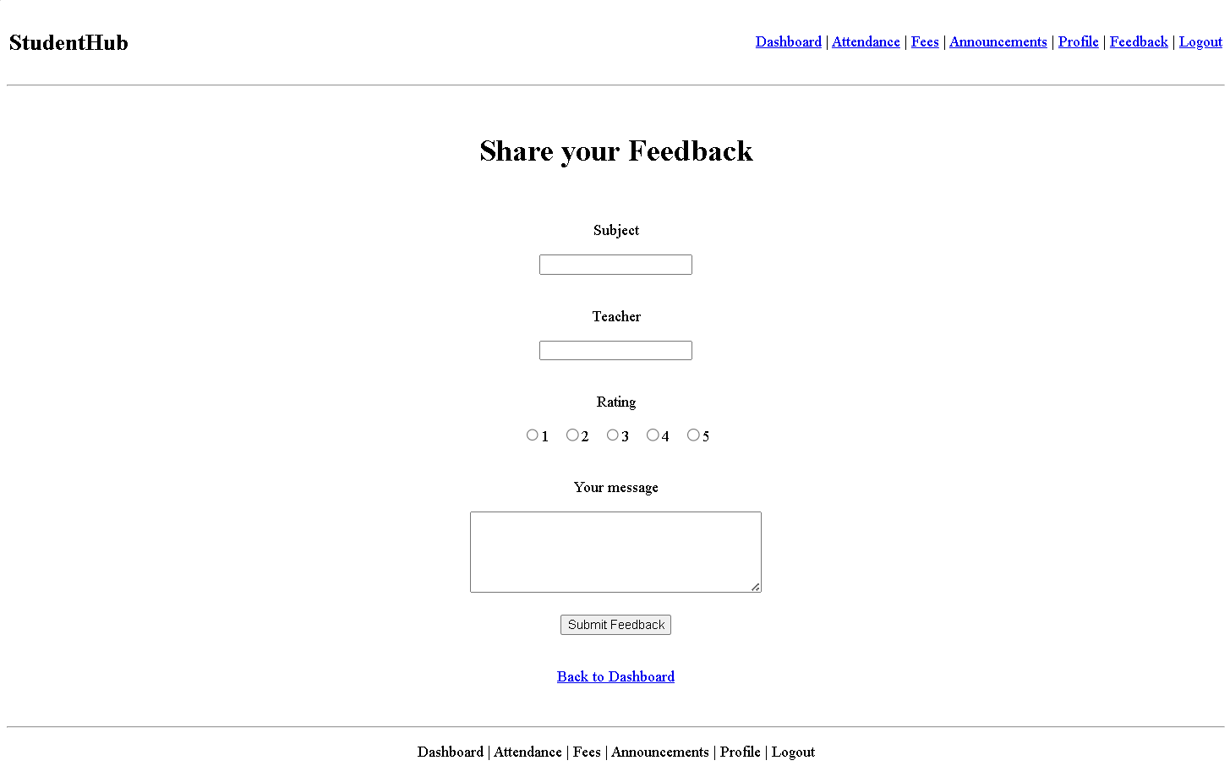

GitHub Repository Link :
https://github.com/kvvaghasiya49/Web_Development.git

Challenges Faced :

The biggest confusion was when to use <section> vs <article> vs <div>. Reading MDN's semantic elements page and checking with the browser's accessibility inspector helped - <article> for standalone content like one event card, <section> for grouped content, and <div> only when no semantic tag fit.

Learning Outcomes :

Learned that semantic tags improve both accessibility and code readability. Understood how screen readers rely on heading order, alt text, and labels, and practiced structuring pages for accessibility from the start instead of fixing it later.

Faculty Remarks :

